# Steps to download and install Pentaho.

Go to http://community.pentaho.com/

You will see the website as below.



Click on Kettle, as shown by the arrow.

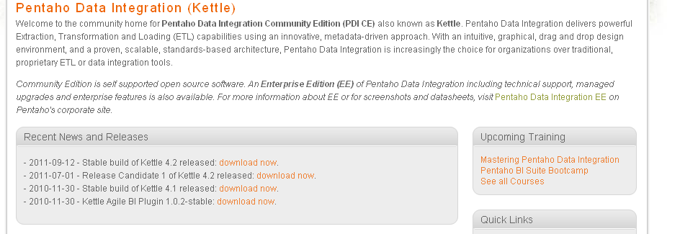

As indicated by the arrow, click on download now for - 2011-09-12 - Stable build of Kettle 4.2 released:

Create a directory **Pentaho 4.2** and save the Zip file under this directory.

Extract contents of compressed file to this directory.

The extract process will create a subdirectory under parent directory **C:\Pentaho-4.2\data-integration**

Create a new environment System variable as below or where ever your jre6 file is.

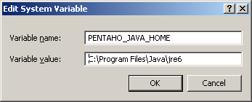

Now double click on Spoon.bat to start Pentaho.

